**Ideation Phase**

**Define the Problem Statements**

|  |  |
| --- | --- |
| Date | 20 June 2025 |
| Team ID | LTVIP2025TMID31055 |
| Project Name | ToyCraft Tales: Tableau's Vision into Toy Manufacturer Data |
| Maximum Marks | 2 Marks |

**Customer Problem Statement Template:**

Create a problem statement to understand your customer's point of view. The Customer Problem Statement template helps you focus on what matters to create experiences people will love.

A well-articulated customer problem statement allows you and your team to find the ideal solution for the challenges your customers face. Throughout the process, you’ll also be able to empathize with your customers, which helps you better understand how they perceive your product or service.

**Example:** *Smartphone User with Low Storage Issues*

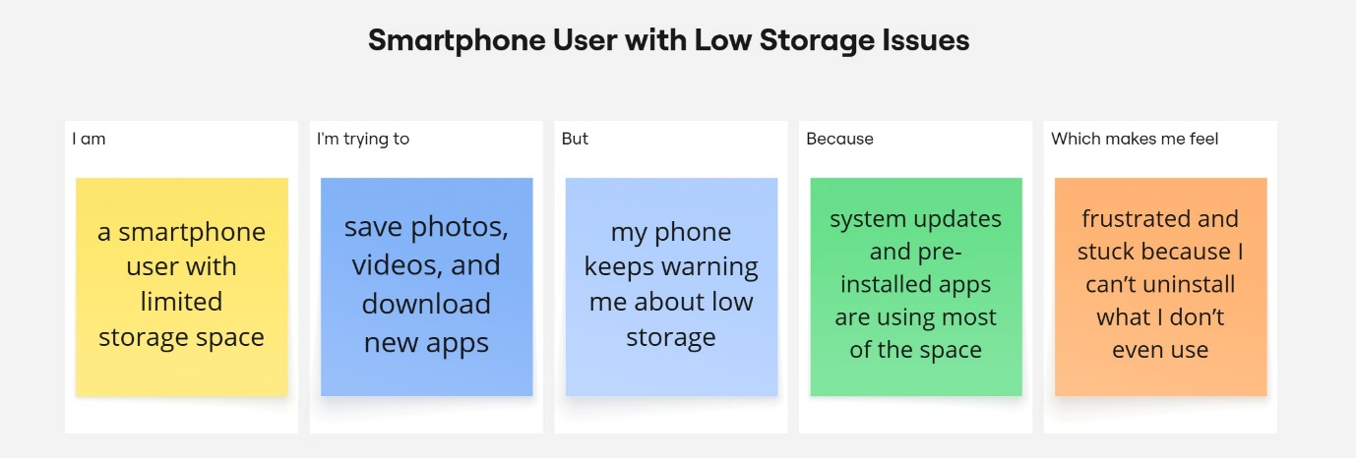

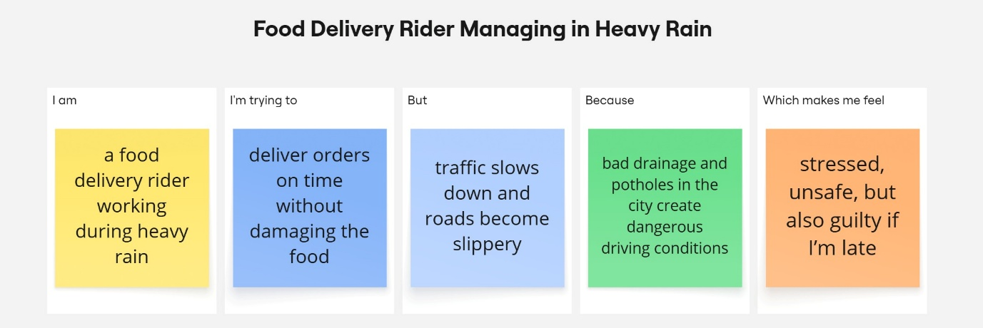

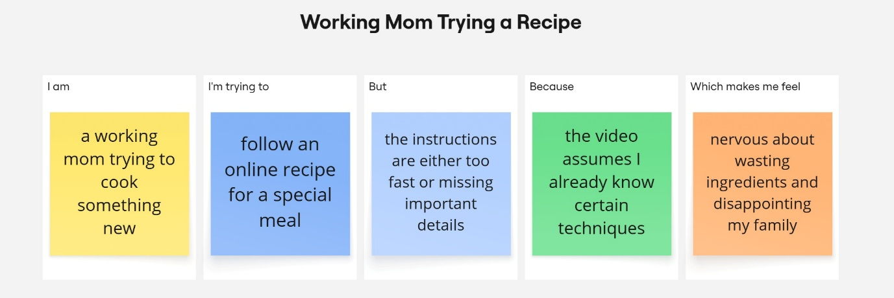

|  |  |  |  |  |  |
| --- | --- | --- | --- | --- | --- |
| **Problem Statement (PS)** | **I am** | **I’m trying to** | **But** | **Because** | **Which makes me feel** |
| PS-1: **Smartphone User with Low Storage Issues** | a smartphone user with limited storage space | save photos, videos, and download new apps | my phone keeps warning me about low storage | system updates and pre-installed apps are using most of the space | frustrated and stuck because I can’t uninstall what I don’t even use |
| PS-2:  **Food Delivery Rider Managing in Heavy Rain** | a food delivery rider working during heavy rain | deliver orders on time without damaging the food | traffic slows down and roads become slippery | bad drainage and potholes in the city create dangerous driving conditions | stressed, unsafe, but also guilty if I’m late |
| PS-3:  **Working Mom Trying a Recipe** | a working mom trying to cook something new | follow an online recipe for a special meal | the instructions are either too fast or missing important details | the video assumes I already know certain techniques | nervous about wasting ingredients and disappointing my family |